**ProofOfConcept PoC: Prevention of the Epidemic CoronaVirus Example**

**Interesting product for remote biomedical monitoring: Smart Bracelet for the Prevention of the Epidemic**

**Smart bracelet for Epidemic Prevention**  
  
By monitoring four biomedical indicators described below, it is possible to identify a possible index of "Immunization" or "immunity" or "health" in a patient  
  
The biomedical values to be monitored are:

1. Body temperature
2. Oxygen dissolved in the blood
3. Blood pressure
4. ECG/EKG electro cardiogram

The sensors implemented in the smart bracelet are respectively:

1. Thermometer
2. Oximeter
3. Sphygmomanometer
4. Electrocardiograph

Data Bluetooth low energy BLE transmitter in realtime without criptography to be remote monitoring:

1. macaddress and hostname
2. RealTime Body temperature
3. RealTime Oxygen dissolved in the blood
4. RealTime Blood pressure
5. RealTime ECG / EKG electro cardiogram
6. RealTime gps position
7. RealTime Immunity Index

Force request in case of index immunity is not ok:

1. macaddress and hostname
2. Last 12h Body temperature
3. Last 12h Oxygen dissolved in the blood
4. Last 12h Blood pressure
5. Last 12h ECG / EKG electro cardiogram
6. Last 12h gps position
7. RealTime Immunity Index

Here are some descriptions of existing products on various commercial market channels:

**Descriptions “bracelet 1”**

*Main features*

T1 Smart Watch Body Temperature Measure Blood Pressure Monitor Heart Rate Fitness Tracker Smart bracelet for Epidemic Prevention   
  
*Main Features:*   
● Health monitoring function: ECG monitoring, heart rate monitoring, blood pressure monitoring, blood oxygen monitoring, etc.   
● Record Sports: Step, calories, distance, track motion query   
● Multiple reminders information: Call information, AA, WeChat, weibo, etc.   
● Sport mode: running, walking, swimming, cycling, climbing, basketball, badmintom, foothball, etc.   
● Life reminder: Sedebtary reminder, meeting reminder, drinking waker reminder, medication reminder, etc.   
  
*App* *Languages:*\* Android: Inglese, Czech, German, Spanish, French, Italian, Japanese, Korean, Portuguese, Russian, Thai, Simplified Chinese, Traditional Chinese   
* IOS: Inglese, Simplified Chinese, Traditional Chinese, Japanese, Korean, Spanish, German, French , Portuguese, Italian, Russian, Polish   
  
*Wristband Languages:*   
* Android: Simplified Chinese, Traditional Chinese, Inglese, French, German, Japanese, Spanish, Italian, Korean, Russian, Czech, Portuguese, Turkish, Hebrew, Greek, Latin, Vietnamese, Danish   
* IOS: Simplified Chinese, Traditional Chinese, Inglese, French, German, Japanese, Spanish, Italian, Korean, Russian, Czech, Portuguese, Turkish, Hebrew, Greek, Latin, Vietnamese, Danish   
  
*Notes:*  
The data is for reference only and is not intended for use with medical data. Patients with hypertension Should be Placed with caution.if you have any questions, pls contact us at the first time, do not easy to open disputes or bad reviews, we will do our best to solve it for you, thank you.   
  
*Packing list:*   
1 * T1 Thermometer bracelet   
1 * Charging Cable   
1 * User Manual   
1 * Retail box

**Descriptions “bracelet 2”**

*Main features*

Description:   
Screen: Screen Size 1.14 inch   
Definition: 240 * 210   
Capacity: 130mA   
Housing material: PC   
Broadband: TPU   
Specification   
CPU type: HS6620   
Heart Rate: WK1069   
RAM: 64KB   
Flash ROM: 512KB   
Acceleration Sensor: G Sensor 3 axis   
Bluetooth: Antenna FPC   
Charger Interface: USB Charger   
key: Touch-screen single pressure   
system: Android 4.4 than   
iOS system version higher than 8.4

*software* *Features*Support Display time, distance, calories, distance, screen, sleep monitor, running track, reminder calls, reminder message, sedentary reminder, reminder alarm, do not disturb, shake and take pictures, search phone, different quadrants, hourly measurement , WeChat movement, heart rate, body temperature, health apple, weekly health Report, Blutooth Name, Language, app name, immunity, blood pressure, blood oxygen, ECG.

*Changer mode*: USB charger   
*Waterproof*: IP67   
*APP support Voice*

*andriod*: English, Czech, German, Spanish, French, Italian, Japanese, Korean, Portuguese, Russian, Thai, Simplified Chinese, Traditional Chinese

*ios*: English, Chinese, Traditional Chinese, Japanese, Korean, Spanish, German, French, Portuguese, Italian, Russian, Polish

*Bracelet Support Language:* Simplified Chinese, Traditional Chinese, English, French, German, Japanese, Spanish, Italian, Korean, Russian, Czech, Portuguese, Turkish, Hebrew, greek, Latin, Vietnamese, Danish

*specifications:*

Touchscreen high-precision capacitive, lightweight and easy to use   
Bluetooth enabled, fitness tracker   
monitoring body temperature   
pedometer, calorie counter, distance, monitor sleep   
Fashion & Durable, great for fitness sports   
  
*packing List:*

bracelet 1 * T1 thermometer   
1 * Charging Cable  
1 * User Manual   
1 * Retail Box   
  
*Note:*

Because of the difference between different monitors, the picture may not reflect the actual c olor product.   
Compare the size of the details with yours, please allow 1-3 cm error due to manual measurement.   
Please leave a message before you give negative feedback if the products have some problems.   
Thank you for your understanding.   
  
*NOTE:*

The data are only for reference purposes and are not intended for use with medical data. Patients with hypertension should be placed carefully. If you have questions, please contact us for the first time, it is not easy to open disputes or negative reviews, we will do our best to solve it for you, thank you.

*Specific:*

*language English waterproof grade Life waterproof*

*Screen Type  LCD Color*

*Band Material Silica*

*Function Fitness Tracker, oxygen in the blood, Tracker Heart Rate, Thermometer, Activity Tracker, Sleep Tracker, Passometer*

*Touch screen Yup*

*Compatibility All compatible*

*Below same product image:*

[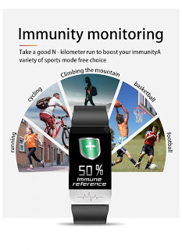](https://1.bp.blogspot.com/-klhQlu7_ZZ8/Xo19TRvjqWI/AAAAAAAAAok/RKVIaZzXL-4wXdBx4zAfit4JkQdqF4tSQCLcBGAsYHQ/s1600/1.jpg)

[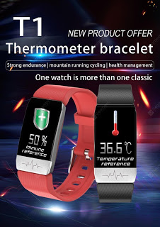](https://1.bp.blogspot.com/-8OZuVN5G1lU/Xo19VsmlmGI/AAAAAAAAAo8/fHb80mTF_wwEs4vZH9bO0E-3SZGXOVL8wCLcBGAsYHQ/s1600/2.jpg)

[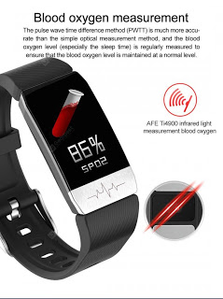](https://1.bp.blogspot.com/-gU-L3gbj-mg/Xo19WDpVE5I/AAAAAAAAApA/VX3NSIUxn0AqRSk9NjIm6TRrBeXGXhy4QCLcBGAsYHQ/s1600/3.jpg)

[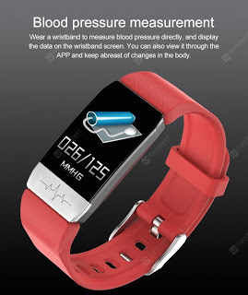](https://1.bp.blogspot.com/-hkKujdZCzQo/Xo19WCbDhKI/AAAAAAAAApE/8CJI262Rl5ktkm_mVVDoFh7UupebidtJwCLcBGAsYHQ/s1600/4.jpg)

[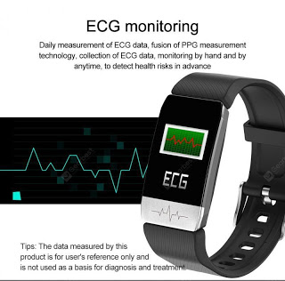](https://1.bp.blogspot.com/-DBWoEqbE8Wk/Xo19WYdRKmI/AAAAAAAAApI/Gfcq2MyTQU8pCKXT0-cRTpfCqbogJhLSACLcBGAsYHQ/s1600/5.jpg)

[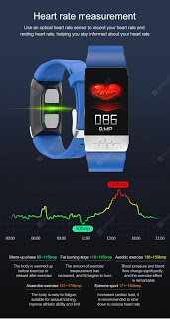](https://1.bp.blogspot.com/-HDW1EV-Spjg/Xo19WsujImI/AAAAAAAAApM/VNybq5jUpxAudO3Jky-eJ_JfUqcLwoT0QCLcBGAsYHQ/s1600/6.jpg)

[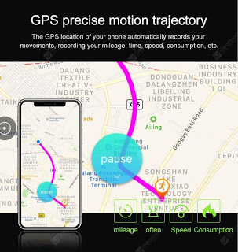](https://1.bp.blogspot.com/-FncVqo8pqH8/Xo19XFXBgoI/AAAAAAAAApQ/Y8Zyja-2U5sckKet0Hw7JjJZWXCdSwXDgCLcBGAsYHQ/s1600/7.jpg)

[[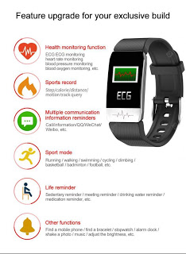](https://1.bp.blogspot.com/-wRPso2K_JJ8/Xo19XSyZ5lI/AAAAAAAAApU/ZyEIoESspBMgt8FhL8jwWqQbd6VU2zAhgCLcBGAsYHQ/s1600/8.jpg)](https://1.bp.blogspot.com/-wRPso2K_JJ8/Xo19XSyZ5lI/AAAAAAAAApU/ZyEIoESspBMgt8FhL8jwWqQbd6VU2zAhgCLcBGAsYHQ/s1600/8.jpg)

[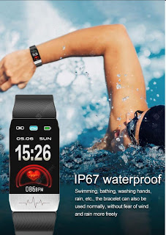](https://1.bp.blogspot.com/-icBkZjvkanQ/Xo19XaoubiI/AAAAAAAAApY/r-i-rimXfd4sd1GXSx2Yb8fnZYeSl5d6ACLcBGAsYHQ/s1600/9.jpg)

[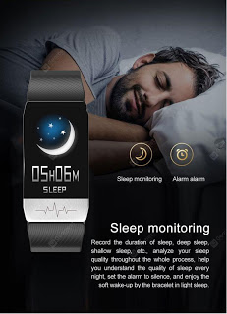](https://1.bp.blogspot.com/-bXULPhWd9Sk/Xo19Td323CI/AAAAAAAAAos/lXFImfAYEMQladkUod72AeEO6OwdIuYAACLcBGAsYHQ/s1600/10.jpg)

[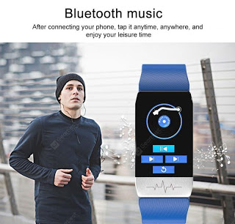](https://1.bp.blogspot.com/-6s64HgYUA7s/Xo19TXC1t3I/AAAAAAAAAoo/bPLFCmuFp8s36R35bExwlTYGE6vt2Wd1QCLcBGAsYHQ/s1600/11.jpg)

[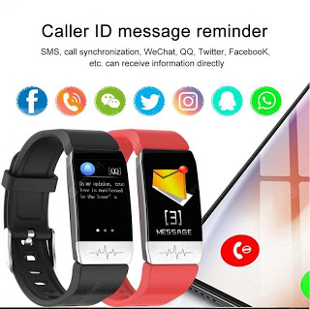](https://1.bp.blogspot.com/-7mo0LrrQFYE/Xo19UfHO5WI/AAAAAAAAAow/gdQPVvRZe1QKz8mcl7fKLfSW_iYDvIq_ACLcBGAsYHQ/s1600/12.jpg)

[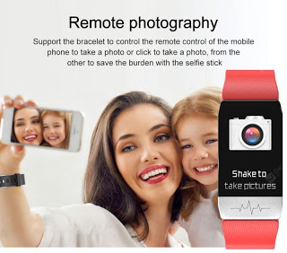](https://1.bp.blogspot.com/-xyP80r6GU_U/Xo19U77fQ4I/AAAAAAAAAo0/ZA7osIIufFM3otrIpsmrKcy2bLOeiGWaQCLcBGAsYHQ/s1600/13.jpg)

[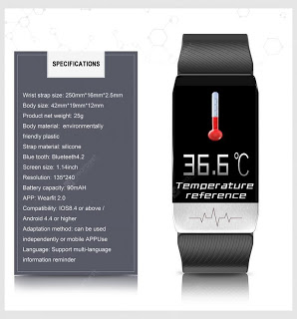](https://1.bp.blogspot.com/-lockZEN0ncQ/Xo19U8C0RzI/AAAAAAAAAo4/MPWBQf-BRIgesEfPhML4D60afTwZNkKGwCLcBGAsYHQ/s1600/14.jpg)

**ProofOfConcept PoC: Smart Bracelet for the Prevention of the Epidemic and Improvement with technologies Bluetooth BLE Radar, Angle of Arrival (AoA) and Angle of Departure (AoD) and Augmented reality (AR)**

**1. Angle of Arrival (AoA) with BLE5.1 on SDR / BLE BLUETOOTH RADAR**   
  
*Software code:* bleaoa  
  
*Tool for measuring Angle of Arrival with BLE5.1 on SDR*  
  
*The demo software can be used to measure the accuracy of the Angle of Arrival (AoA) technique adopted in Bluetooth Low Energy (BLE) 5.1. The software runs on Software-Defined Radios (SDR) manufactured by Ettus Research.*  
  
*Components included*  
  
*The programs included in this package run on systems that are connected to SDR platforms. The program running on a specific system depends on the role of the SDR in the experimental setup (transmitter or receiver).*   
  
*In particular, the package includes:*  
  
*•        aoatransmitter: the transmitter sends BLE packets periodically (beacons). We have used this program with a USRP N200 SDR.  
•        aoareceiver: the receiver captures the beacons and process them in order to determine the AoA of the transmitter. We have used this program with a USRP B210 SDR.  
  
The software has been tested on Ubuntu 18.04 and 16.04.*  
  
*Share Link:* <https://github.com/bsnet/bleaoa>  
  
  
  
**2. Silicon Labs example Angle of Arrival (AoA) and Angle of Departure (AoD) Technology management**  
 *Bluetooth Direction Finding: Angle of Arrival (AoA) and Angle of Departure (AoD)  
The Bluetooth 5.1 specification enhances location services with a direction finding feature that makes it possible to detect the direction of a Bluetooth signal. With Bluetooth direction finding, developers can bring products to market that understand device direction and achieve sub-meter location accuracy.*  
*Link:* <https://www.silabs.com/products/wireless/learning-center/bluetooth/bluetooth-direction-finding>  
  
  
  
**3. Bluetooth BLE radar App,  several Screenshot of Android / iOS apps**   
  
*Some screenshots of android and iOS applications that should work as radar and indicate the spatial position with respect to the operator.*

[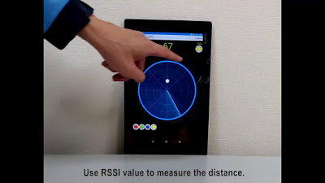](https://1.bp.blogspot.com/-aTAx18sI_9U/Xo2C_WS-5AI/AAAAAAAAAp4/qgEJEAs8rqYGJYGL8kM_lsUaPAegaenzQCLcBGAsYHQ/s1600/a.jpg)

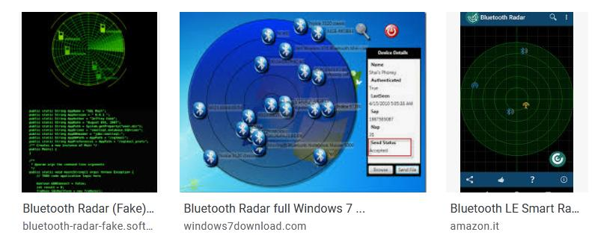

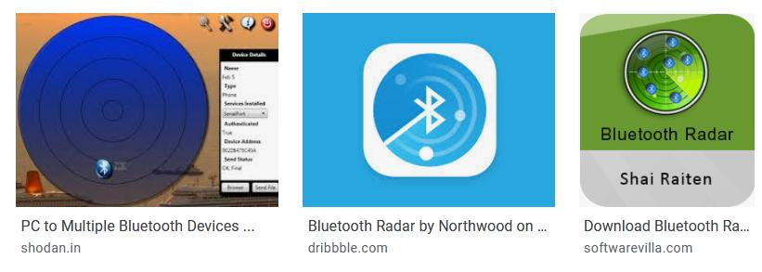

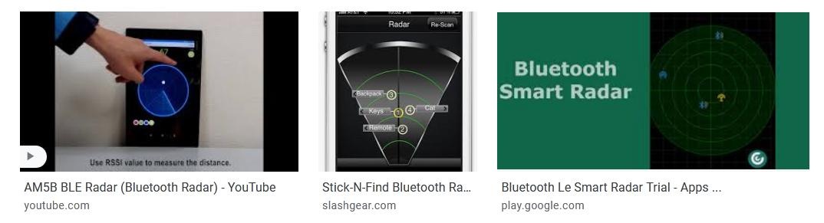

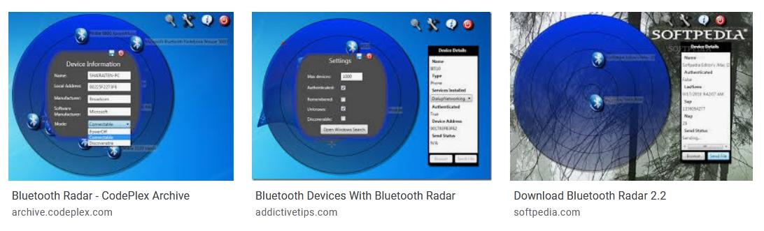

**4. Augmented Reality AR recognition immunity index realtime**  
  
*Interpolating the bluetooth scans, the reception of messages, augmented reality it is possible to identify on the road any people to check*

[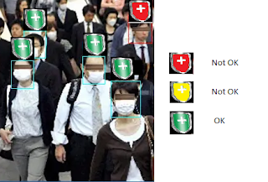](https://1.bp.blogspot.com/-u9aKiAbzVZo/Xo2IlxsMz1I/AAAAAAAAAqc/-AVwbvkn01gLoCZ2mw4bHzyBXCoh8EliACLcBGAsYHQ/s1600/VR.png)

**ProofOfConcept PoC how to use "software defined radio" to intercept and examine people's movements**

**What data interception and monitoring to analyzer**  
  
**1.TIMSI**

* *Temporary IMSI GSM Protocol*

**2. RTL_433 ISM Band Open message decoder**

* *TMPS*
* *KeyFob*
* *Status of House or shop Alarm*

**3. RTL SDR AMR Protocol Smart Energy or Smart Meter Remote Reader**

* *scm*
* *scm+*
* *idm*
* *netidm*
* *r900*
* *r900bcd*
* *Other Smart Meter Protocol*

**4. MACADDRESS WiFi 2.4 and 5Ghz**

* *Phone MacAddress*
* *PC MacAddress*
* *Car MacAddress*

**5. MACADDRESS BT**

* *Phone MacAddress*
* *PC MacAddress*
* *Car MacAddress*

**6. MACADDRESS BLE**

* *Phone MacAddress*
* *Smart Watch MacAddress*
* *PC MacAddress*
* *Car MacAddress*
* *Car Key MacAddress*
* *Car speaker phone MacAddress*

**7. nRF-Mousejack**

* *Mouse*
* *Keyboard*

**8. RFID Long and Short Range**

* *Car Key*
* *Car RFID Ignition System*
* *Proxymity reader car parking*
* *Pet microchip*
* *Contactless Smart Car*

**Example Code to receive and decode radio message**

1. IMSI-catcher <https://github.com/Oros42/IMSI-catcher>
2. RTL_433 <https://github.com/merbanan/rtl_433> & <https://github.com/kismetwireless/kismet>
3. RTL AMR [https://github.com/bemasher/rtlamr &](https://github.com/bemasher/rtlamr) <https://github.com/kismetwireless/kismet>
4. MacAddress WiFi <https://github.com/kismetwireless/kismet>
5. MacAddress BT <https://github.com/kismetwireless/kismet>
6. MacAddress BLE <https://github.com/kismetwireless/kismet>
7. nRF Mousejack <https://github.com/kismetwireless/kismet>
8. RFID Long Short <https://github.com/Iskuri/RTLSDR-NFC>

**Example of Medical Implantable or subcutaneous infusion Device with wireless communication:**

* *Implantable Pacemakers*
* *Implantable Cardiac Defibrillators*
* *Implantable Chip FDX-B ISO 11784 11785 RFID NFC*
* *Implantable Cochlear implants*
* *Implantable Foot Drop implants*
* *Implantable Gastric Stimulators*
* *Implantable Deep Brain Neurostimulators*
* *Continuous subcutaneous infusion Pump insulin*
* *Blood Sugar Meter/ Glucometers*

**For a stronger control a Wearable device macro-category with wireless communication:**

* *Smart Accessories, semi-autonomous devices that connect to the Network and that can perform some functions without the support of other technological devices;*
* *Complex Accessories, devices that in order to be fully operational require connection to another device, which acts as a 'bridge' for connection. Think of the watches or bracelets that are used to monitor physical activity, require the support of another device;*
* *Smart Wearables, devices that operate in complete autonomy, independently managing to connect to the Network but also to perform actions such as browsing or downloading.*

**Example Code:**

* Implantable Pacemakers
* Implantable Cardiac Defibrillators
* *Implantable Chip FDX-B ISO 11784 11785 RFID NFC*
* Implantable Cochlear implants <https://github.com/JiaoXianjun/BTLE> & <https://github.com/ZhangLei-cn/ble-sniffer> & <https://github.com/jocover/BLESDR> &<https://github.com/floe/BTLE><https://github.com/omriiluz/NRF24-BTLE-Decoder>
* Implantable Foot Drop implants
* Implantable Gastric Stimulators
* Implantable Deep Brain Neurostimulators <https://github.com/ps2/rtlmm>
* Continuous subcutaneous infusion Pump insulin <https://github.com/ps2/rtlmm>
* Blood Sugar Meter / Glucometers <https://github.com/nlefler/astro>

**News:**  
  
*Sniffing MiniMed Insulin Pump RF Packets with an RTL-SDR*  
  
<https://www.rtl-sdr.com/sniffing-minimed-insulin-pump-rf-packets-with-an-rtl-sdr/>  
  
*Using a HackRF SDR to Withhold Treatment from an Insulin Pump*  
  
<https://www.rtl-sdr.com/using-a-hackrf-sdr-to-withhold-treatment-from-an-insulin-pump/>  
  
*Discuss: SDR to locate cochlear implants*  
  
<https://www.rtl-sdr.com/forum/viewtopic.php?t=2139>  
  
*Sniffing Data from an Implanted Heart Defibrillator*   
  
<https://www.rtl-sdr.com/tag/implanted-cardiac-defibrillator/>  
  
*Hack causes pacemakers to deliver life-threatening shocks*  
  
<https://arstechnica.com/information-technology/2018/08/lack-of-encryption-makes-hacks-on-life-saving-pacemakers-shockingly-easy/>

**ProofOfConcept PoC V2.0 : Technology Prevention, Biomedical Monitoring, People's movements, Medical Screening CheckPoint of the Epidemic CoronaVirus Example**

Continuing the discussion and advancing with implementations of ProofOfConcept PoC: Technology Prevention, Biomedical Monitoring, People's movements of the Epidemic CoronaVirus Example  
  
***Link:***   <https://giammaiot.blogspot.com/2020/04/proofofconcept-poc-prevention-of.html>

**New possible features software of Pandemic Smart Watch:**

1. ***Manage*** *Pandemic* ***Alerts and State Directives***
2. ***Manage*** *and* ***monitor time slots*** *for* ***outdoor outings, shopping, work, school, shopping, sports***
3. ***Electronic Pass*** *management with* ***QRCode, BarCode, WiFi Code, Bluetooth Code, RFID / NFC Code and mor*e**

**New features hardware of Pandemic Smart Watch and Others Device:**

1. ***Implement bluetooth*** *in the* ***home communication device*** *like modem or router (deleting the connection to the mobile phone device)*
2. *Implement* ***wireless*** *and* ***moving  charging*** *(power generators in contact with the skin)*
3. ***Gates****,* ***Gateways*** *and* ***Repeaters*** *for* ***control on the road*** *using (use of invisible barriers such as radio or physical barriers such as turnstiles for access control)*

**Possible economic implementation:**

1. *Implemented* ***CryptoPandEuroBond similar Crypto-Coronavirus using and modulating pandemic monitoring data***

**Medical Screening CheckPoint Instrumentation on the Road:**  
  
*As confirmation of the data recorded and propagated by the epidemic smartwatch, "Class A" instruments and technological supports that could be supplied to the road surveillance bodies are indicated below.*  
  
**"Class A" Field Instrument Compact All-In-One Multi-parameter Patient Monitor or separate / single Instruments:**

1. Thermometer
2. Oximeter
3. Sphygmomanometer
4. Electrocardiograph

[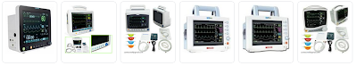](https://1.bp.blogspot.com/-WgtEvBugGc0/Xo3ACVi2l6I/AAAAAAAAAqo/9yPdOOZkAoAHUlUD2CC2j1m7YGSxZzVKACLcBGAsYHQ/s1600/Instruments_allinone.png)

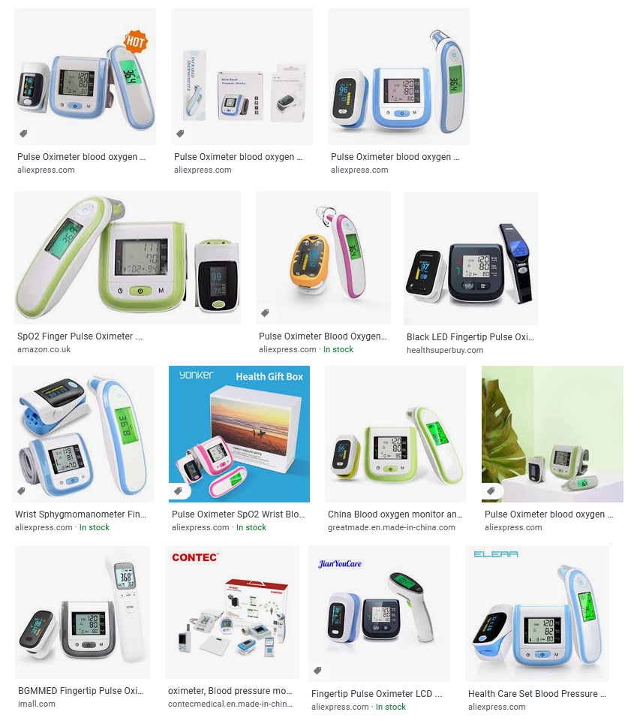

Mobile Device:

1. VR headsets for Augmented Reality AR
2. Tablet for Augmented Reality AR
3. Tablet for Radar/AoA/AoD BLE
4. PC for Radar/AoA/AoD BLE

